# CS 255 System Design Document Template

This template lays out all the different sections that you need to complete for Project Two. Each section has guidance to prompt your thinking. You will need to continually reference the interview transcript as you work to make sure that you are addressing your client’s needs. There is no required length for the final document. Instead the goal is to complete each section based on what your client’s needs are. Remove this note when you are finished, and replace all bracketed text with the relevant information.

## UML Diagrams

### UML Use Case Diagram

### UML Activity Diagrams

### UML Sequence Diagram

### UML Class Diagram

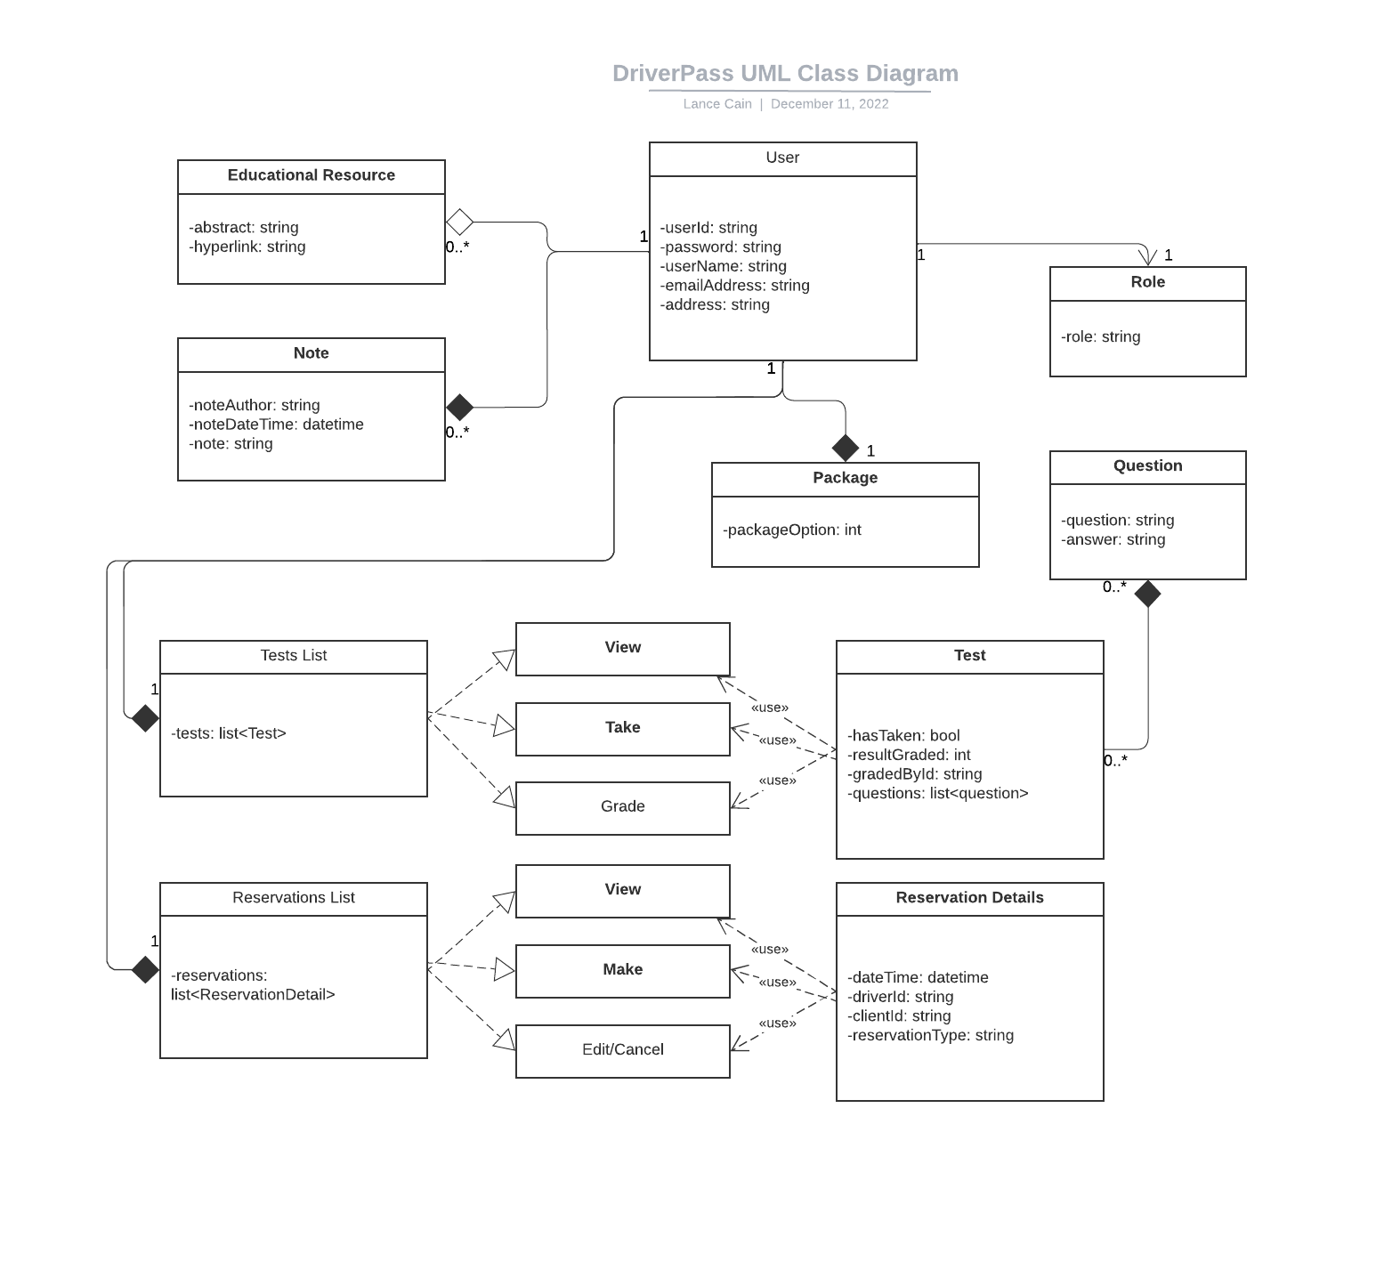

## Technical Requirements

The proposed DriverPass system would be created using a website hosted on a cloud service such as Microsoft Azure or another cloud service capable of hosting a .NET asp based webpage. Using a pre-existing framework such as Blazor will allow us to reduce costs in user interface development and focus on security and stability. Visual studio has all the necessary tools for development and publishing of the webpage to a cloud based host.